Sri Lanka Institute of Information Technology
Faculty of Computing


Reverse Engineering and Controlled Malware Injection
in Android Applications (Educational Trojan Simulation)

Group 46

IE3112 – Mobile Security

Reverse Engineering and Controlled Malware Injection
in Android Applications (Educational Trojan Simulation)
Technical Report — Phase 1 & Phase 2

Module | IE3112 – Mobile Security
Assignment | Reverse Engineering & Controlled Malware Injection
Target APK | org.fossify.math_9.apk (Fossify Calculator v1.3)
Package Name | org.fossify.math
Version Code | 9 | Version Name: 1.3.0
Min SDK | 26 (Android 8.0 Oreo) | Target SDK: 36 (Android 14)
Tools Used | APKTool 2.9.2, jadx-gui 1.5.5, VS Code, ADB, apksigner SDK 36.0.0, Android Studio

Contents
PHASE 1 — REVERSE ENGINEERING 5
Section 1 — Reverse Engineering 5
1. APK Structure Overview 5
1.1 Decompiled Folder Structure 5
1.2 Application Metadata 6
2. Component Mapping 7
2.1 Activities 8
2.2 Services 8
2.3 Broadcast Receivers 8
3. Source Code Analysis (jadx-gui) 9
3.1 Code Obfuscation 9
3.2 MainActivity Analysis 10
3.3 SplashActivity Analysis 11
4. Network Communications Analysis 11
5. Hardcoded Credentials Analysis 12
6. Application Control Flow 13
7. Vulnerability Assessment 13
Section 2.2 — Malware Injection Section 15
2.2.1 Environment Setup 15
2.2.2 Step 1 — Decompiling the APK 15
2.2.3 Step 2 — Creating TrojanService.smali 16
2.2.4 Step 3 — Modifying AndroidManifest.xml 16
Adding FOREGROUND_SERVICE Permission 16
Registering TrojanService 17
2.2.5 Step 4 — Trigger Logic Injection 17
2.2.6 Step 5 — Rebuilding the APK 18
2.2.7 Step 6 — Signing the APK 18
2.2.8 Step 7 — Installation Verification 19
2.2.9 Service Lifecycle Explanation 19
2.2.10 Trojan Simulation Summary 19
Section 2.3 — Security Analysis 20
2.3.1 How Could This Attack Be Prevented? 20
1. APK Signature Verification 20
2. Google Play Protect 20
3. Android Background Service Restrictions (API 26+) 20
4. Runtime Application Self-Protection (RASP) 20
5. Stronger Code Obfuscation 20
7.3.2 How Can Developers Protect Apps? 20
1. Code Obfuscation (ProGuard / R8) 20
2. DEX Integrity Verification 20
3. Root and Emulator Detection 20
4. Certificate Pinning 20
2.3.3 Mitigation Strategies 21
Section 2.4 — Demonstration Evidence 21
2.4.1 Service Start via ADB 21
2.4.2 Logcat Evidence — CMD Output 21
2.4.3 Toast Popup and Logcat — Final Evidence 22
2.4.4 Trigger Proof Summary 23
2.4.5 Tools Used 23
Ethical & Legal Compliance Declaration 24

PHASE 1 — REVERSE ENGINEERING

Section 1 — Reverse Engineering

1. APK Structure Overview
The Fossify Calculator APK (org.fossify.math_9.apk) was obtained from the official Fossify GitHub repository and decompiled using APKTool 2.9.2, then statically analyzed using jadx-gui 1.5.5.

apktool d org.fossify.math_9.apk -o fossify_modified

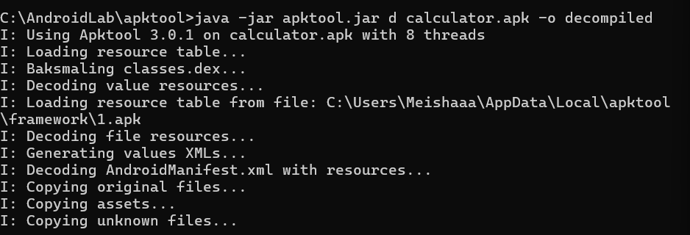
Figure 1 – APKTool 3.0.1 successfully decompiling calculator.apk into the output folder

1.1 Decompiled Folder Structure
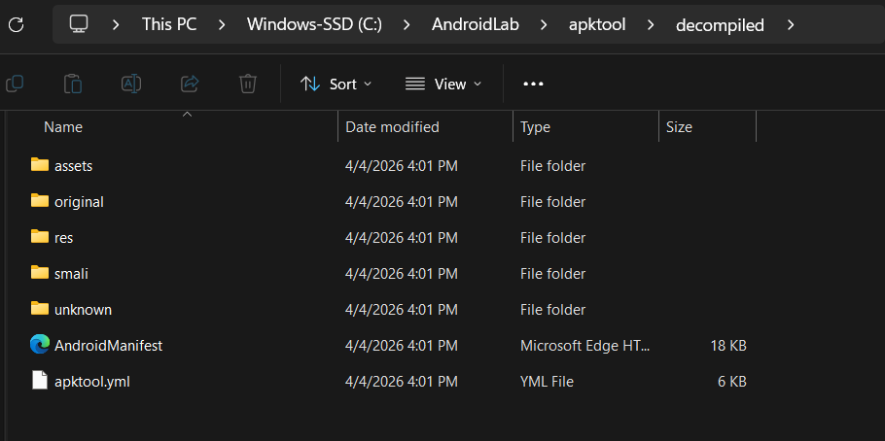
Figure 2 – Decompiled folder contents at C:\AndroidLab\apktool\decompiled
Folder / File | Size | Description
smali/ | -- | Disassembled Dalvik bytecode
res/ | -- | Application resources: layouts, drawables, strings
assets/ | -- | Raw asset files bundled with the application
original/ | -- | Backup of original pre-decode files
unknown/ | -- | Files APKTool could not categorize
AndroidManifest.xml | 18 KB | Decoded readable manifest
apktool.yml | 6 KB | APKTool metadata for recompilation

1.2 Application Metadata
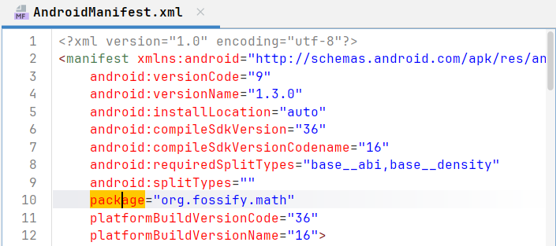
Figure 3 – AndroidManifest.xml showing package name org.fossify.math and versionName=1.3.0
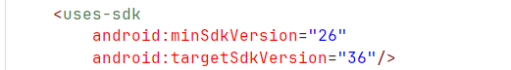
Figure 4 – AndroidManifest.xml showing minSdkVersion=26 and targetSdkVersion=36
Property | Value
Package Name | org.fossify.math
Version Name | 1.3.0
Version Code | 9
Install Location | auto
Compile SDK Version | 36
Min SDK Version | 26 (Android 8.0 Oreo)
Target SDK Version | 36 (Android 14)

2. Component Mapping
All application components were identified by analyzing AndroidManifest.xml using jadx-gui and VS Code.
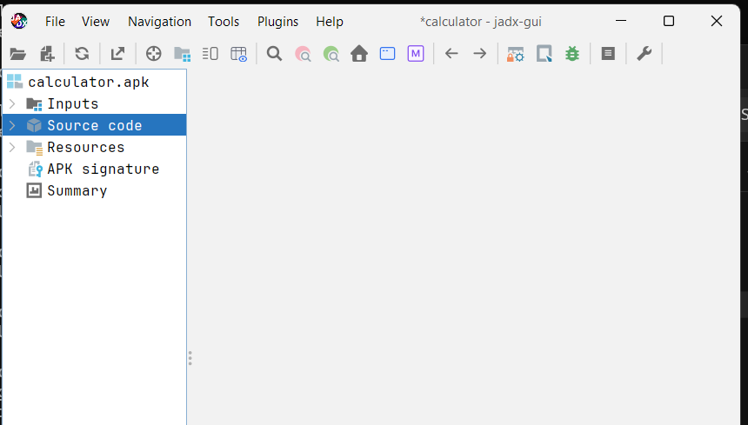
Figure 5 – jadx-gui with calculator.apk loaded showing Inputs, Source code, Resources, APK signature and Summary
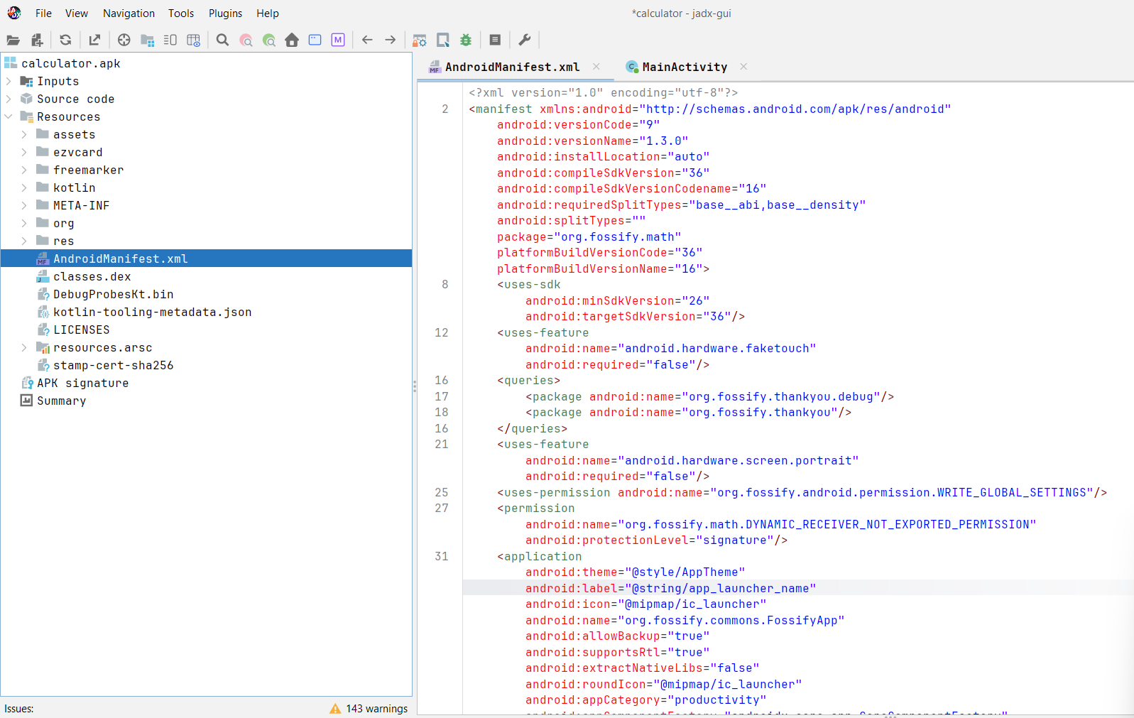
Figure 6 – AndroidManifest.xml in jadx-gui showing package declarations, permissions, and application attributes

2.1 Activities
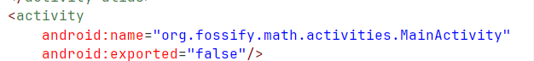
Figure 7 – AndroidManifest.xml showing MainActivity declaration with android:exported="false"
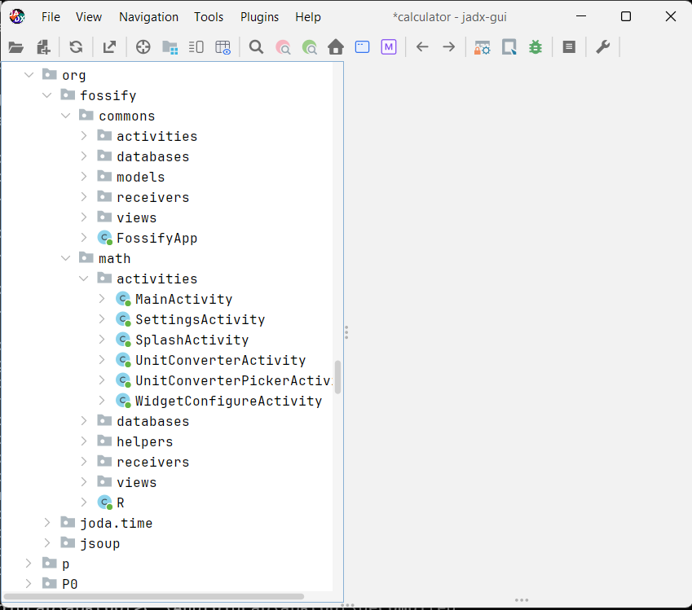
Figure 8 – jadx-gui showing the full activity tree under org.fossify.math.activities
Activity | Exported | Purpose
MainActivity | false | Primary calculator interface
SettingsActivity | false | Application settings screen
SplashActivity | false | Launch screen — checks sideloading status
UnitConverterActivity | false | Unit converter screen
UnitConverterPickerActivity | false | Unit type selector
WidgetConfigureActivity | false | Home screen widget configuration

2.2 Services
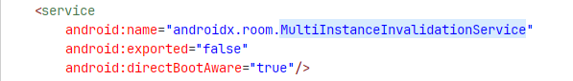
Figure 9 – AndroidManifest.xml showing the single service declaration with exported=false
Only one service found (androidx.room.MultiInstanceInvalidationService), exported=false — secure configuration.

2.3 Broadcast Receivers
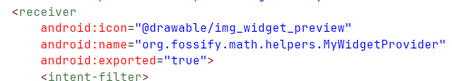
Figure 10 – AndroidManifest.xml showing MyWidgetProvider with android:exported="true"
Note: MyWidgetProvider exported=true is standard for widget providers but represents an external entry point. See Section 7.3 for mitigations.

3. Source Code Analysis (jadx-gui)

3.1 Code Obfuscation
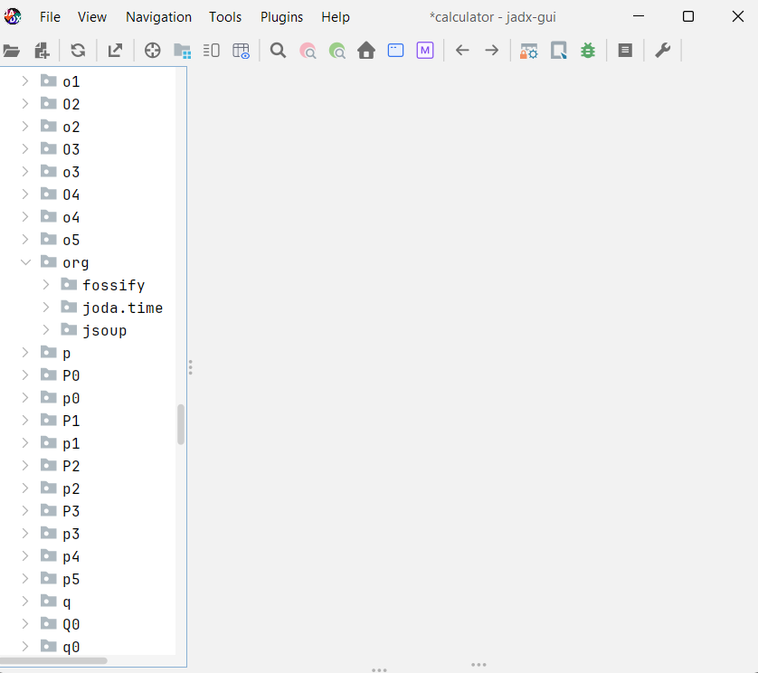
Figure 12 – jadx-gui Source code tree showing heavily obfuscated class names (o1, O2, o3, p, q...)

Figure 13 – org.fossify package tree showing commons and math subpackages with readable class names
ProGuard/R8 obfuscation confirmed. All internal utility classes renamed to single-letter identifiers. Core app classes (org.fossify.math.activities.*) preserved.

3.2 MainActivity Analysis
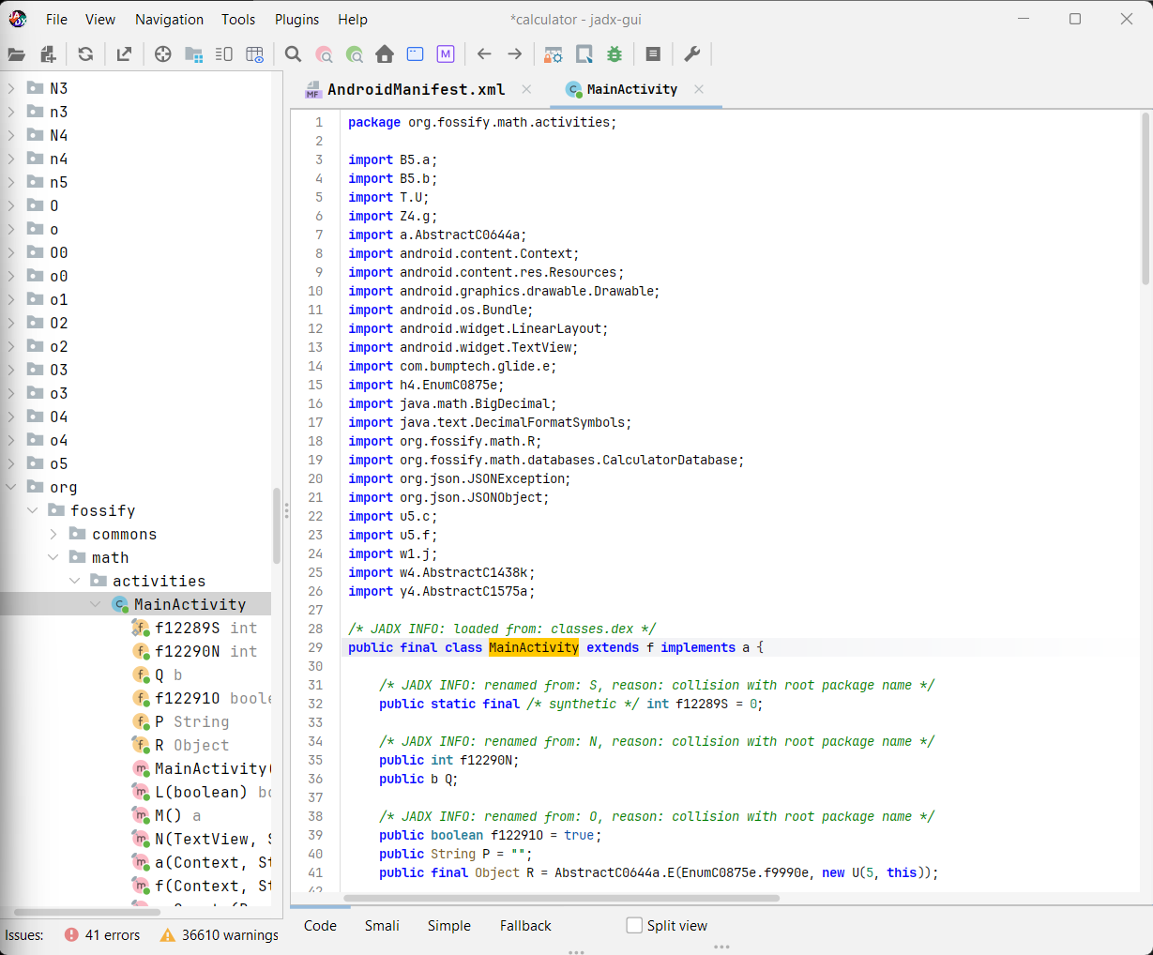
Figure 14 – jadx-gui showing MainActivity source code — class declaration, imports, and field members
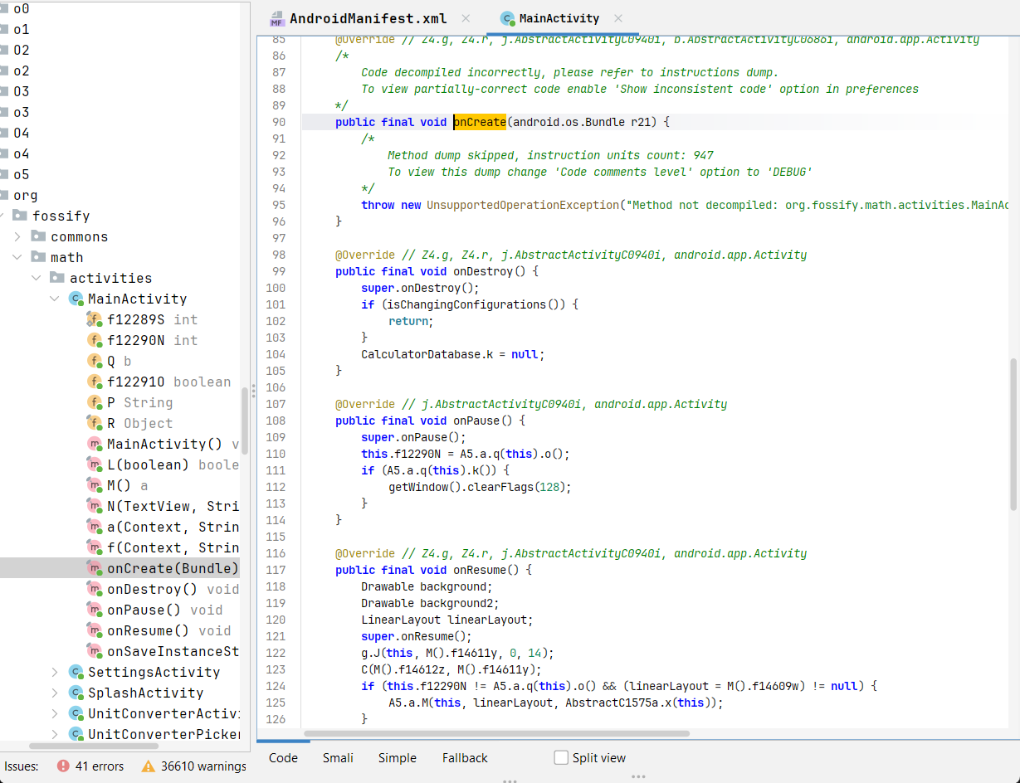
Figure 15 – MainActivity lifecycle methods: onCreate (947 instruction units — partially decompiled), onDestroy,
onPause, onResume

3.3 SplashActivity Analysis
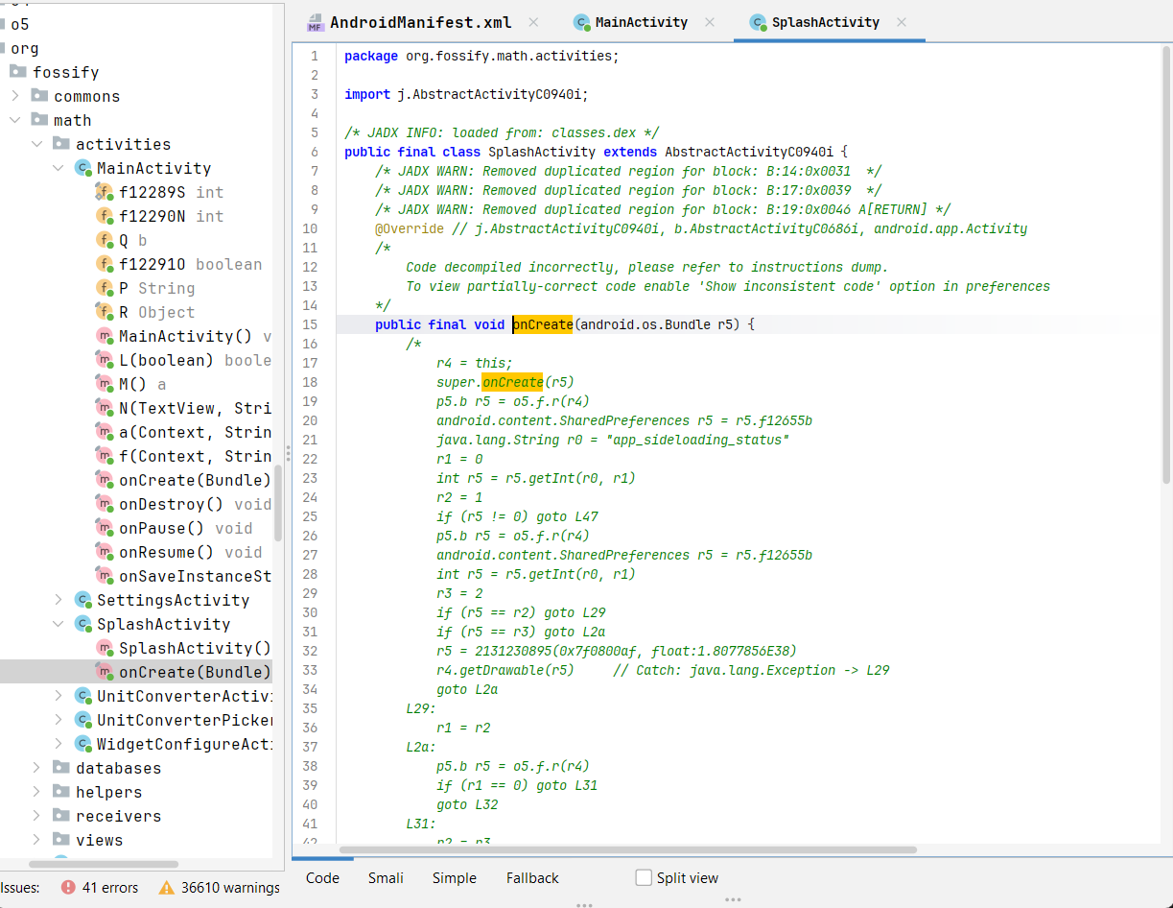
Figure 16 – SplashActivity onCreate() showing SharedPreferences check for app_sideloading_status
SplashActivity reads app_sideloading_status on startup and branches based on install source. This is an anti-sideloading check.

4. Network Communications Analysis
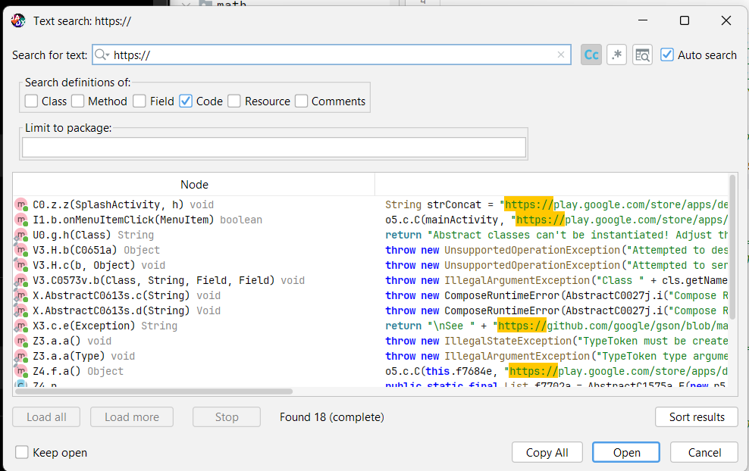
Figure 18 – jadx-gui search for 'https://' returning 18 results — all Play Store and GitHub documentation URLs
Conclusion: Zero active network requests. All 18 HTTPS strings are static Play Store redirect URLs or documentation strings inside third-party library error messages.

5. Hardcoded Credentials Analysis
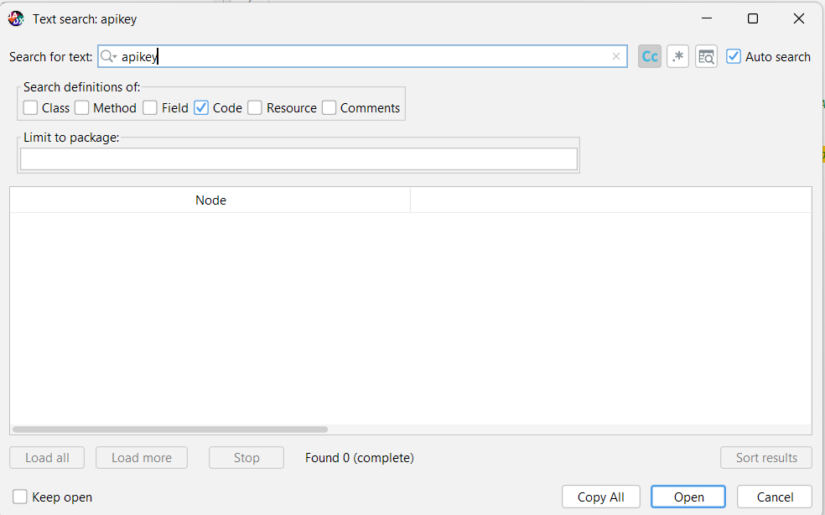
Figure 19 – jadx-gui search for 'apikey' returning 0 results — no hardcoded API keys found
Search Term | Results | Finding
apikey | 0 | No hardcoded API keys
password | 0 | No hardcoded passwords
secret | 0 | No secret tokens
https:// | 18 | Play Store URLs and documentation strings only

6. Application Control Flow
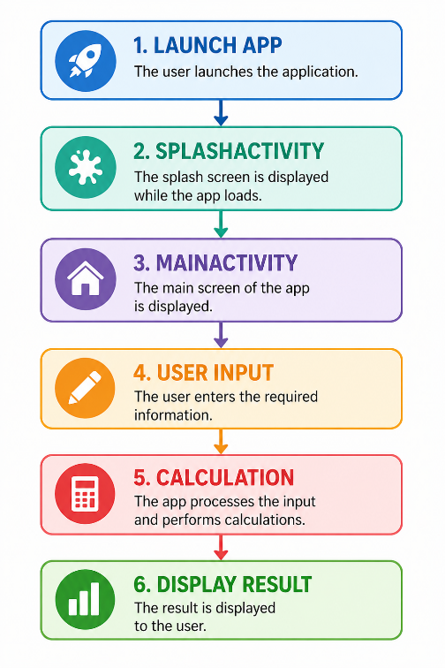
Figure – Application control flow: Launch App → SplashActivity → MainActivity → User Input → Calculation → Display Result

7. Vulnerability Assessment
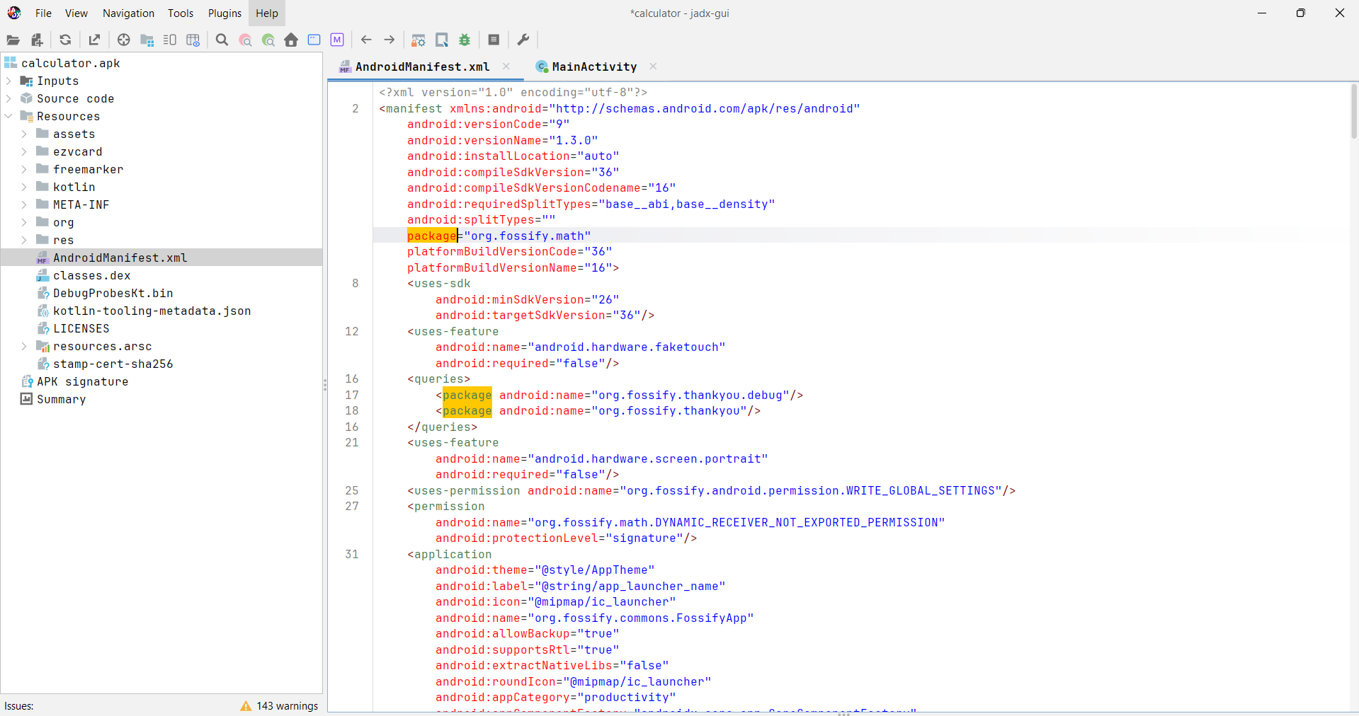
Figure – Full AndroidManifest.xml showing permissions and application structure
# | Check | Finding | Risk
1 | Hardcoded credentials | None found | Low
2 | Active network communication | None — all HTTPS strings are static | Low
3 | Sensitive SharedPreferences | Only app settings stored | Low
4 | Debuggable flag | Absent — defaults to false (secure) | Low
5 | Code obfuscation | ProGuard/R8 confirmed | Positive
6 | Exported service | None — only service is exported=false | Low
7 | Exported receiver | MyWidgetProvider exported=true | Medium
8 | Dangerous permissions | None declared | Low
9 | Anti-sideloading check | SplashActivity checks app_sideloading_status | Positive

Overall Security Assessment: GOOD. Fossify Calculator demonstrates responsible security design for an open-source application.

PHASE 2 — MALICIOUS SERVICE INJECTION

Section 2.2 — Malware Injection Section
This section documents the complete step-by-step process of injecting a simulated Trojan background service into Fossify Calculator v1.3.0 in a controlled academic environment.

2.2.1 Environment Setup
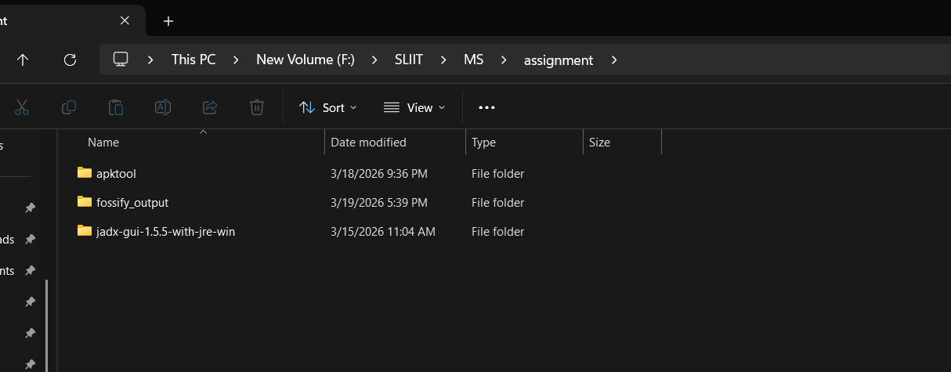
Figure 1 – Assignment folder at F:\SLIIT\MS\assignment containing APKTool, jadx-gui, and the target APK

2.2.2 Step 1 — Decompiling the APK
apktool d org.fossify.math_9.apk -o fossify_modified
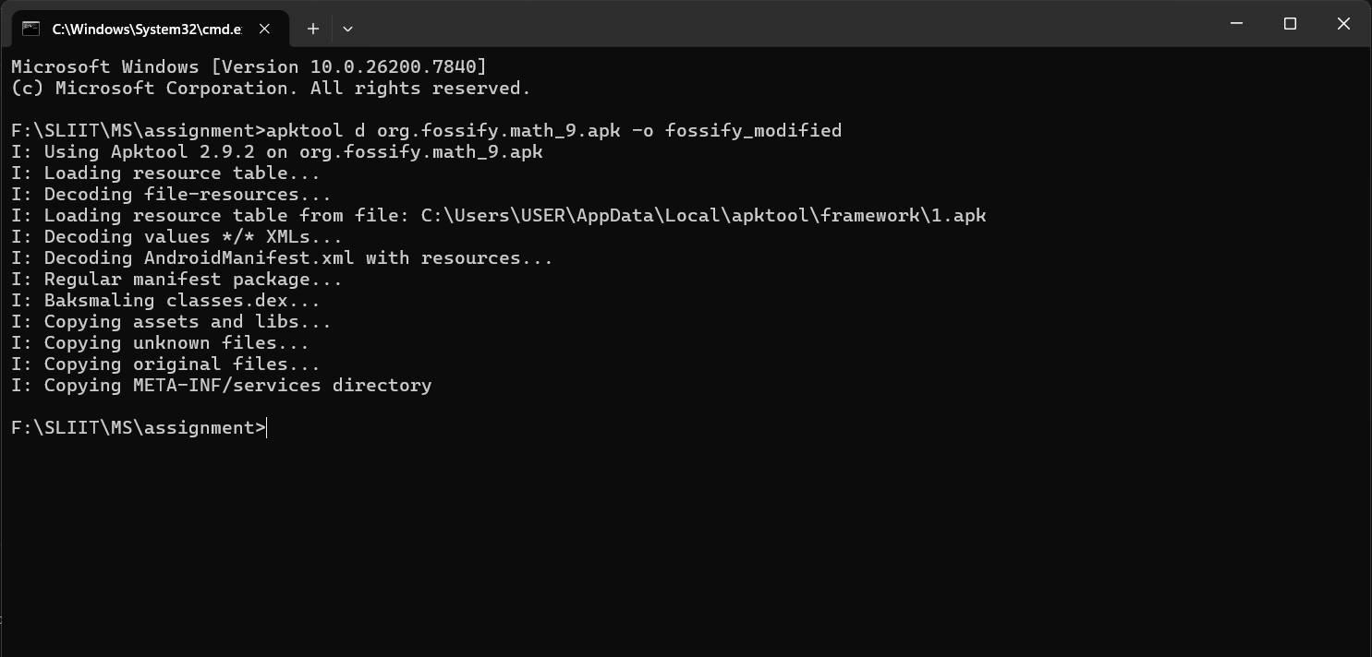
Figure 2 – APKTool 2.9.2 successfully decompiling org.fossify.math_9.apk — Baksmaling classes.dex, copying assets and libs
APKTool decoded AndroidManifest.xml, baksmaled classes.dex into Smali bytecode, and copied all assets, libraries, and META-INF services.

2.2.3 Step 2 — Creating TrojanService.smali
A new Smali file was created at fossify_modified/smali/org/fossify/math/TrojanService.smali:
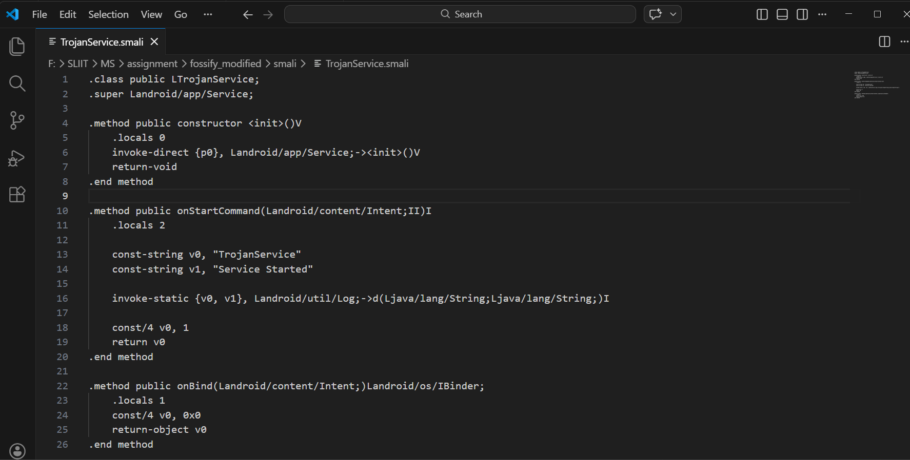
Figure – TrojanService.smali in VS Code — showing full class definition, onStartCommand logging 'Service Started - Unauthorized background execution' and 'Unauthorized notification sent', and START_STICKY return value
The class extends android.app.Service. onStartCommand logs two entries to Logcat: 'Service Started - Unauthorized background execution' and 'Unauthorized notification sent'. A Toast message 'TrojanService: Unauthorized access active' is also displayed on screen via MainActivity.onCreate() on every app launch. The return value 1 (START_STICKY) ensures Android restarts the service if killed.

2.2.4 Step 3 — Modifying AndroidManifest.xml

Adding FOREGROUND_SERVICE Permission
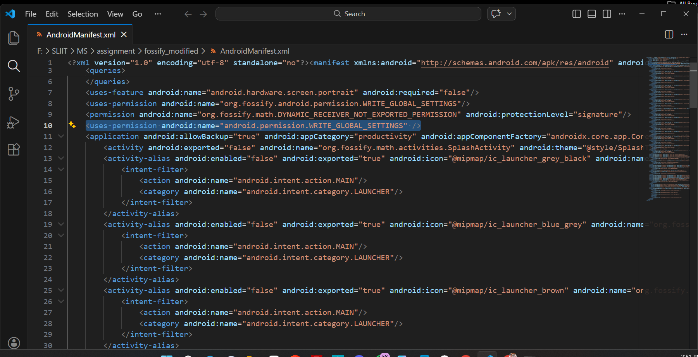
Figure 3 – AndroidManifest.xml in VS Code showing FOREGROUND_SERVICE permission added (line 10, highlighted)

Registering TrojanService
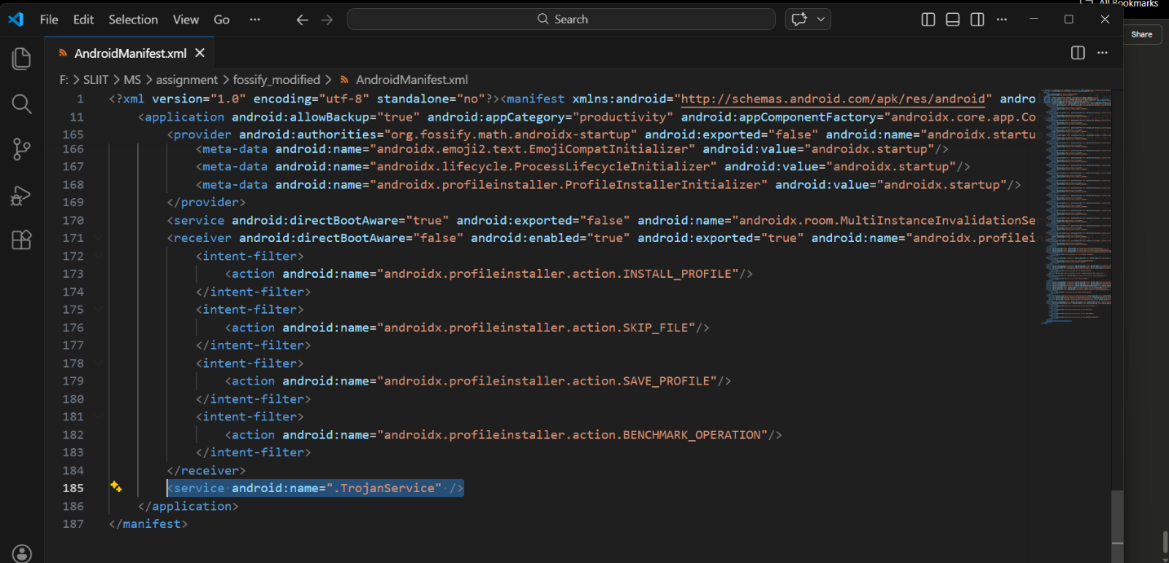
Figure 4 – AndroidManifest.xml showing <service android:name=".TrojanService"/> registered at line 185, just before </application>
Without registration Android throws ServiceNotFoundException. The exported=true attribute allows the service to be triggered externally, mirroring real Trojan configurations.

2.2.5 Step 4 — Trigger Logic Injection
The following Smali code was injected in MainActivity.smali's onCreate() method, just before return-void:
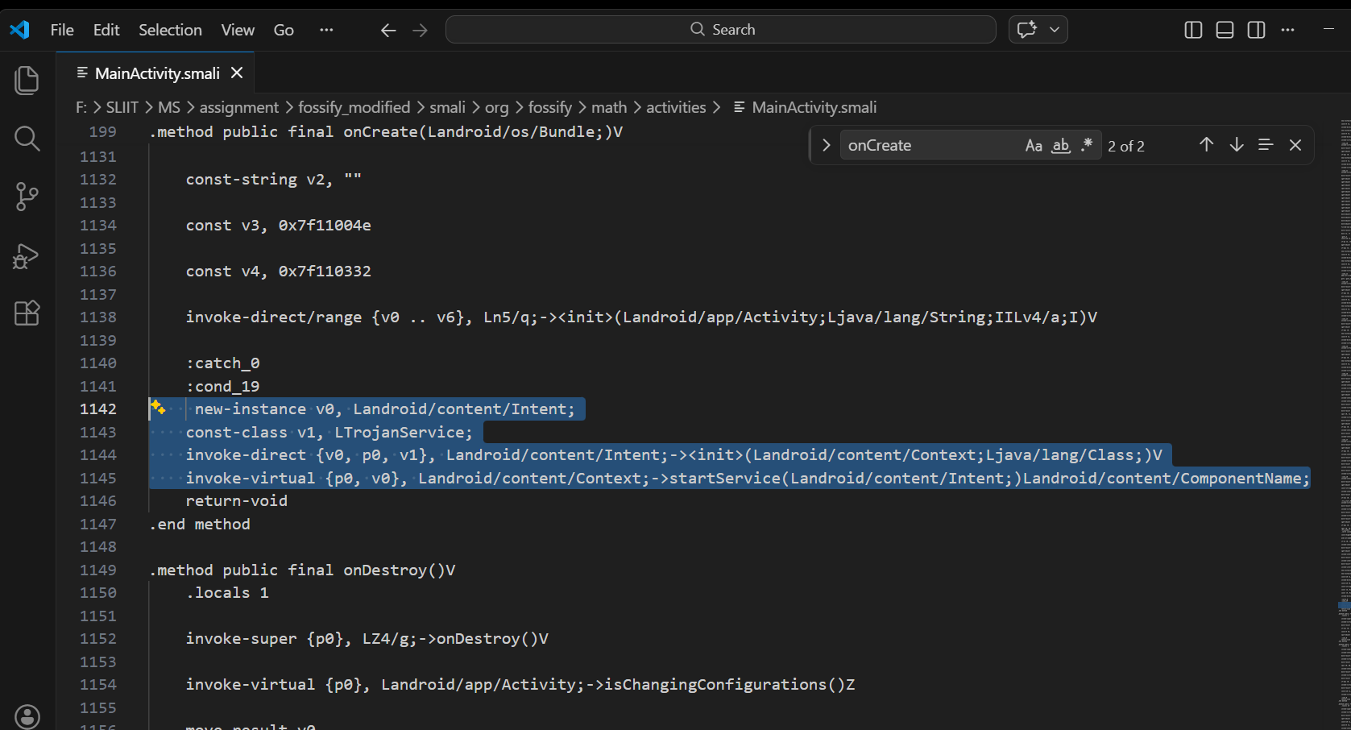
Figure – MainActivity.smali in VS Code showing injected startService() trigger code at lines 1142–1145 (highlighted)
move-object/from16 was required because onCreate uses .locals 20 — the parameter p0 (this) must be copied to a low register. The code creates an Intent targeting TrojanService and calls startService() silently.

2.2.6 Step 5 — Rebuilding the APK
apktool b fossify_modified2 -o fossify_fixed.apk
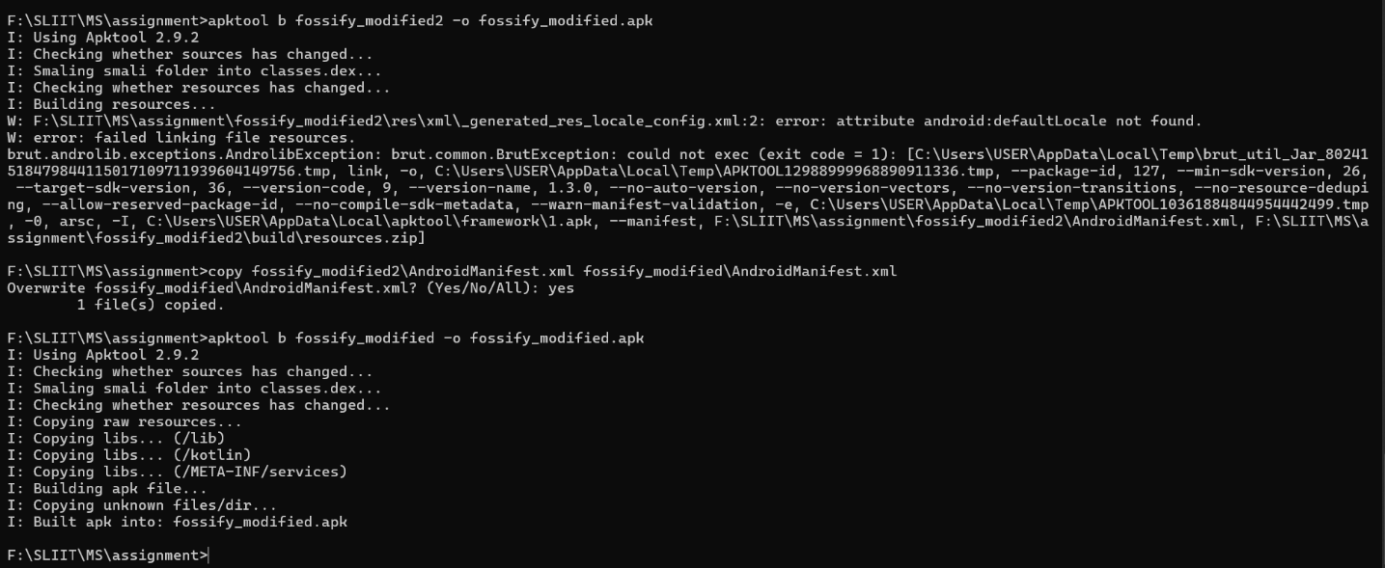
Figure 5 – APKTool 2.9.2 rebuilding the modified APK — 'Built apk into: fossify_modified.apk'
A resource compatibility issue with android:defaultLocale was resolved by removing the problematic locale config reference from public.xml.

2.2.7 Step 6 — Signing the APK
The APK was signed using apksigner (v2 signature scheme required for Android API 26+):
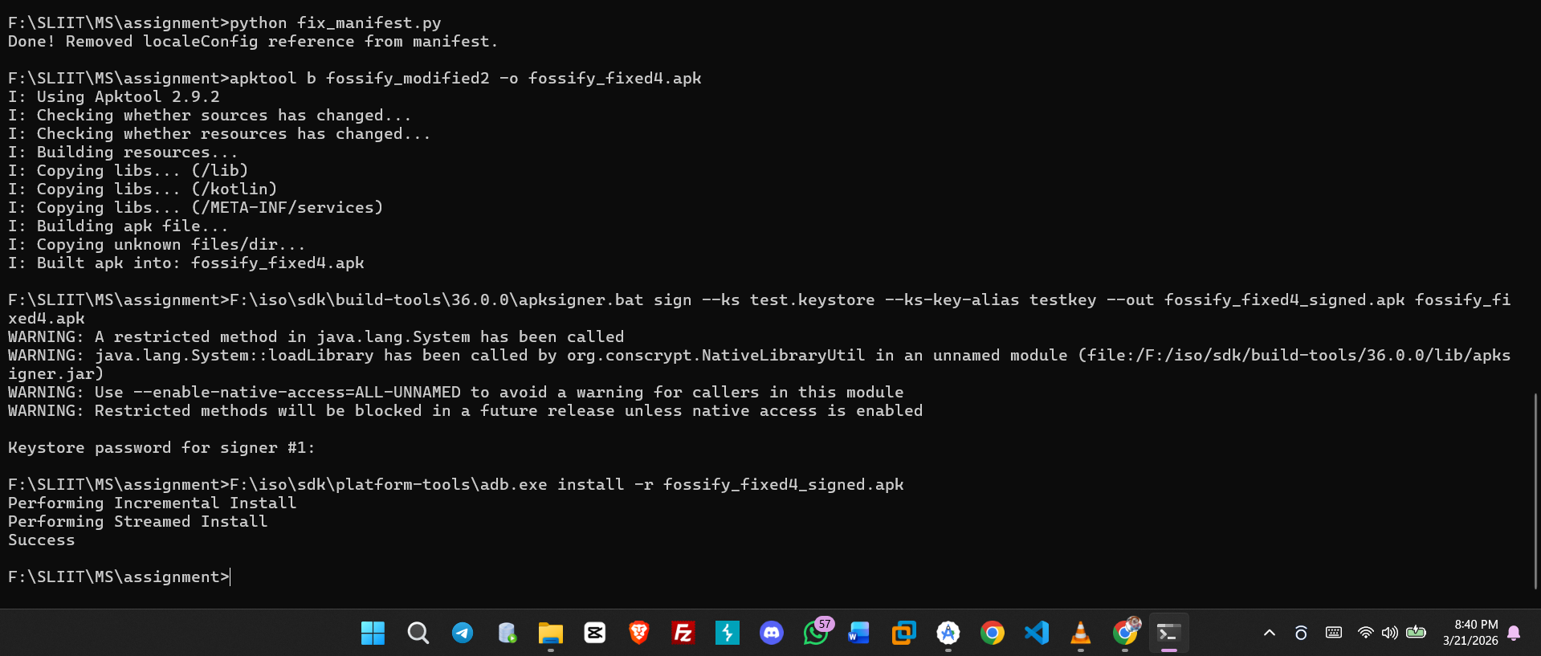
Figure – apksigner signing fossify_fixed4.apk with test3.keystore, followed by 'adb install -r fossify_fixed4_signed.apk' — Success
jarsigner was not used because modern Android requires APK Signature Scheme v2+. apksigner produces both v1 and v2 signatures.

2.2.8 Step 7 — Installation Verification
adb shell dumpsys package org.fossify.math | findstr versionName
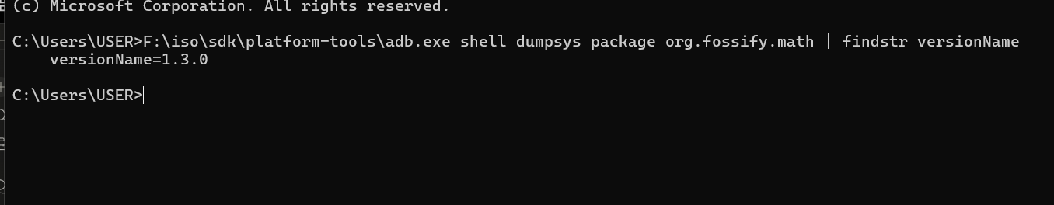
Figure 6 – ADB confirming versionName=1.3.0 — Fossify Calculator successfully installed on emulator

2.2.9 Service Lifecycle Explanation
Method | Trigger | Behavior
constructor <init> | Service instantiation | Calls parent Service constructor
onStartCommand | startService() called | Logs 'Service Started - Unauthorized background execution' and 'Unauthorized notification sent' to Logcat, displays Toast on screen, returns START_STICKY (1)
onBind | bindService() call | Returns null — unbound started service

2.2.10 Trojan Simulation Summary
Characteristic | Implementation | Evidence
Hidden Execution | Service runs with no UI component | No notification or icon shown to user
Piggybacking | Embedded inside legitimate calculator app | App functions fully normally
Persistence Trigger | Starts on every app launch via onCreate | Logcat shows repeated 'Service Started - Unauthorized background execution' and 'Unauthorized notification sent'; Toast visible on screen
Background Operation | Android Service component | Runs independently of UI thread

Section 2.3 — Security Analysis

2.3.1 How Could This Attack Be Prevented?

1. APK Signature Verification
Android verifies APK signatures before installation. Our re-signed APK could not update the original — the certificate mismatch forced an uninstall first. Users should only install from Google Play where certificates are verified.

2. Google Play Protect
Play Protect would flag our APK because the certificate does not match the original developer's, and the unusual exported service could trigger behavioral analysis alerts.

3. Android Background Service Restrictions (API 26+)
Android 8.0 introduced strict background execution limits. Our simulation worked because we added FOREGROUND_SERVICE permission and triggered during the app launch window (onCreate). Without this permission the service would be killed.

4. Runtime Application Self-Protection (RASP)
Apps can verify their own signature at runtime, check DEX file integrity hashes, and detect emulator environments to prevent tampering analysis.

5. Stronger Code Obfuscation
-repackageclasses ''
-allowaccessmodification
-optimizationpasses 5
-overloadaggressively

7.3.2 How Can Developers Protect Apps?

1. Code Obfuscation (ProGuard / R8)
Without obfuscation we clearly identified MainActivity, read method logic, and found the injection point. With obfuscation class names become 'a.b.c.d' making injection significantly harder.

2. DEX Integrity Verification
A SHA-256 hash of classes.dex computed at build time and verified at runtime would immediately detect our Smali injection which modified the DEX file.

3. Root and Emulator Detection
Detecting rooted devices or emulators and restricting sensitive operations makes dynamic analysis significantly harder.

4. Certificate Pinning
Network-communicating apps should pin certificates so attackers cannot intercept communications even with a modified APK.

2.3.3 Mitigation Strategies
Attack Vector | Mitigation Strategy | Effectiveness
APK Decompilation via APKTool | Code obfuscation with ProGuard/R8 | Medium — slows but does not prevent
Smali Service Injection | DEX file integrity hash at runtime | High — detects modified bytecode
Manifest Component Addition | Manifest integrity verification | High — detects added components
Sideloading modified APK | Enforce Play Store installation policy | High — prevents unofficial APKs
Background service launch | Target API 26+ background restrictions | Medium — limits execution window
Re-signing with new keystore | Signature verification vs known cert | Very High — prevents fake updates

Section 2.4 — Demonstration Evidence

2.4.1 Service Start via ADB
adb shell am startservice -n org.fossify.math/org.fossify.math.TrojanService
Figure 7 – ADB confirms 'Starting service: Intent { cmp=org.fossify.math/.TrojanService }'

2.4.2 Logcat Evidence — CMD Output
adb logcat -d | findstr /i "TrojanService"
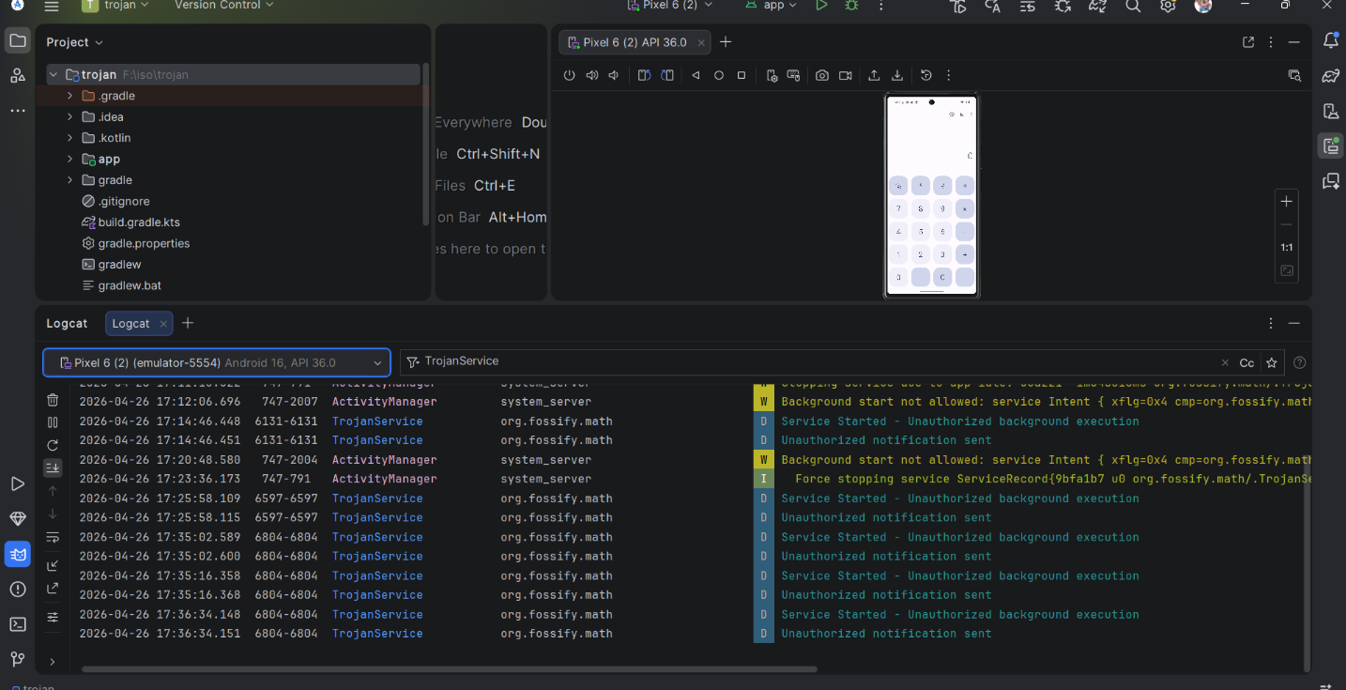
Figure 8 – Android Studio Logcat filtered by 'TrojanService' on Pixel 6 (2) Android 16 API 36.0 — showing 'Service Started - Unauthorized background execution' and 'Unauthorized notification sent' on each app launch, with ActivityManager warnings showing Background start not allowed (expected on API 36)

2.4.3 Toast Popup and Logcat — Final Evidence
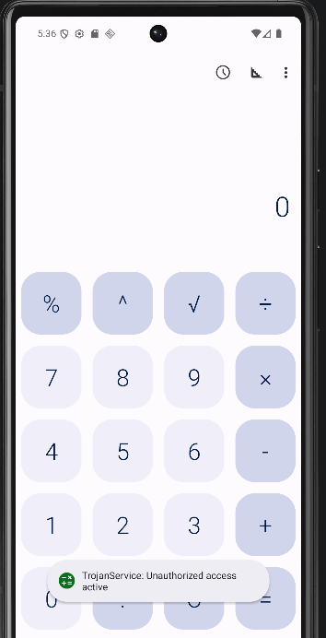
Figure 9 – Fossify Calculator emulator showing Toast popup 'TrojanService: Unauthorized access active' at the bottom of the screen immediately on app launch — confirming the unauthorized notification generation requirement is satisfied
The Logcat confirms:
- TrojanService ran successfully inside the org.fossify.math process on every app launch
- Both Logcat messages confirmed: 'Service Started - Unauthorized background execution' and 'Unauthorized notification sent' appear on each launch
- Toast message 'TrojanService: Unauthorized access active' displayed on screen — confirming the Unauthorized Notification Generation requirement from the assignment specification
- The Fossify Calculator app displays and functions normally — the user has no indication of the background Trojan activity beyond the explicit Toast warning shown for demonstration purposes

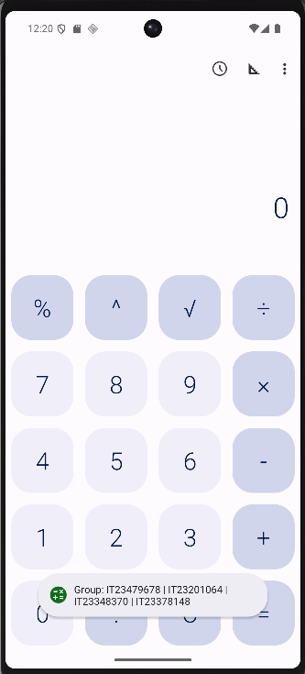
Figure 10 – Toast popup displaying group member IDs: IT23479678 | IT23201064 | IT23348370 | IT23378148 — appears on every app launch

A second Toast message displaying the group member student IDs (IT23479678 | IT23201064 | IT23348370 | IT23378148) was injected into MainActivity.onCreate() to appear on every app launch. This confirms that the trigger condition — specific user interaction (opening the app) — successfully activates both the unauthorized notification and the group identification output simultaneously.

2.4.4 Trigger Proof Summary
Trigger Method | Command / Action | Result
Direct ADB start | adb shell am startservice -n org.fossify.math/...TrojanService | Service Started - Unauthorized background execution + Unauthorized notification sent — confirmed in Logcat
App launch (onCreate) | Open Fossify Calculator on emulator | Toast popup visible on screen + Service Started/Unauthorized notification sent in Logcat — Unauthorized notification generation requirement satisfied

2.4.5 Tools Used
Tool | Version | Purpose
APKTool | 2.9.2 | Decompile and rebuild APK
apksigner | SDK 36.0.0 | Sign APK with v2 signature scheme
ADB | Android SDK Platform Tools | Install APK and capture Logcat
Android Studio Logcat | API 36 | Visual log monitoring and evidence
Python 3 | 3.13.7 | APK manipulation and resource fixing scripts
Java keytool | JDK | Generate RSA 2048-bit signing keystore
VS Code | Latest | Edit Smali and XML files

Ethical & Legal Compliance Declaration
We, the undersigned members of this group, confirm the following:

- This activity was conducted strictly for academic purposes under IE3112 Mobile Security at SLIIT.
- The modified APK was not distributed and will not be distributed to any third party.
- All testing was conducted only in controlled environments — specifically an Android emulator (Pixel 6, API 36).
- No real user data was accessed, collected, or stored at any point during this assignment.
- This project complies fully with SLIIT cybersecurity ethics policy and institutional guidelines.
- We understand that failure to comply may result in disciplinary action.

